Question 1)

1. Position : Security staff – Westfield RICCARTON

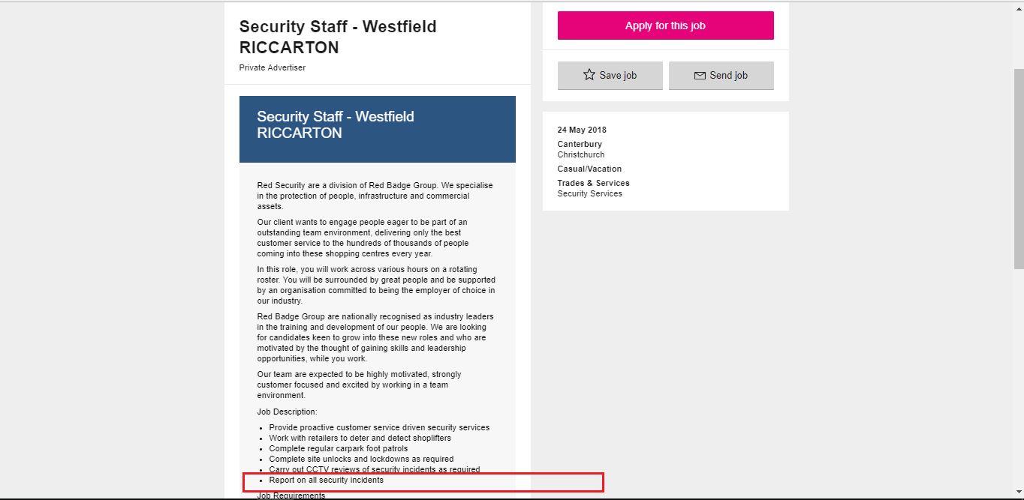

* As the job description above, i choose “Report on all security incidents” as my favorite task
* Within IT security roles, this Security Staff is in the Incident Response management Team which decide and perform functions related to security incidents report.
* As a security staff, the “Report on all security incidents” is associated with the MONITOR Security Controls(SP 800-137) which is a step 6 in Risk management Framework.

1. Position: Information Security Consultant

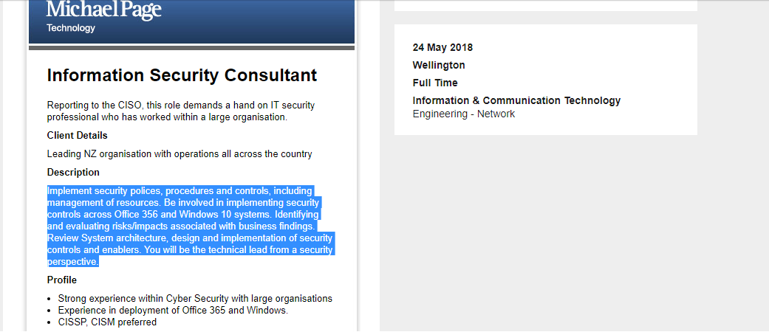

* As the job description above, my tasks are to implement security polices, procedures and controls including management of resources, implement security controls across Office 465 and Windows 10 systems.
* I think, these implementation tasks are in the IMPLEMENT Security Control which is step 3 in RMF.

1. Position : IT Audit – cyber security

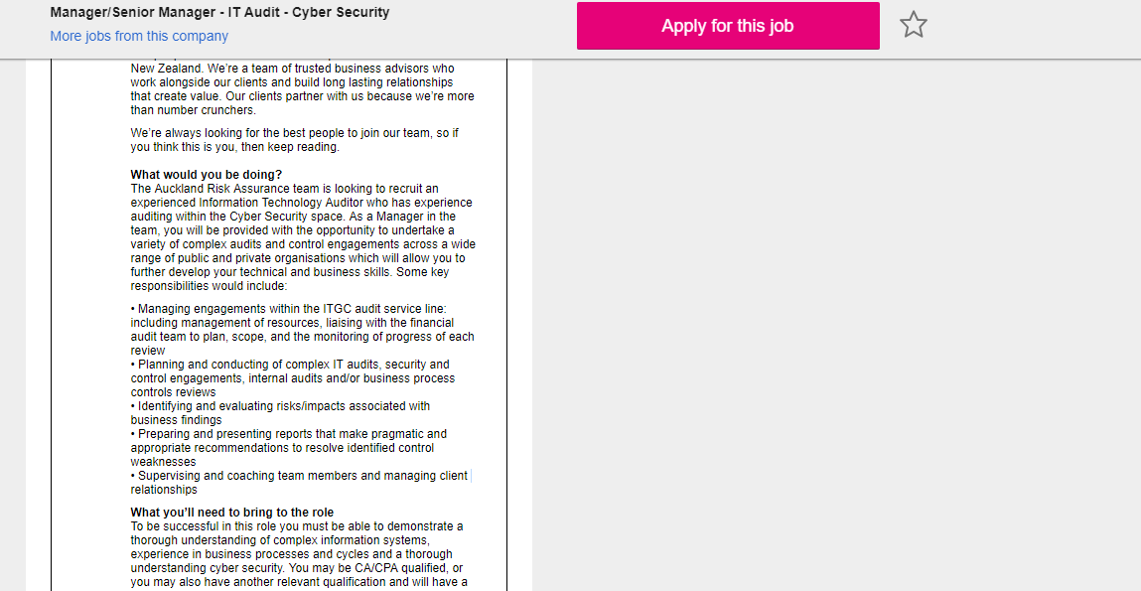

* As the description above, as a manager, i can undertake a variety of complex audits and control engagements.
* Undertaking a variety of complex audits and controlling engagements tasks, i think, belong to ASSESS Security Controls which is step 4 of RMF.

1. Position : Network and Security Specialist

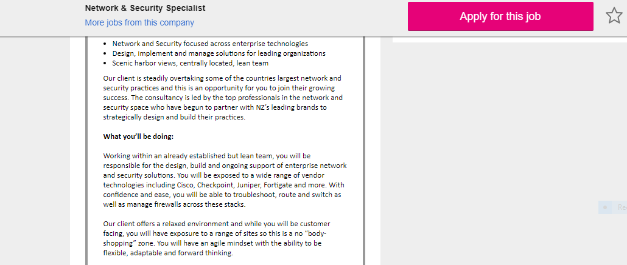

* As the description above, i can build and support of enterprise network and security solutions and be able to troubleshoot and manage firewalls across the stacks.
* These tasks are the “IMPLEMENT Security controls” and “AUTHORIZE Information Systems “ which belong to step 4 and step 6 respectively in RMF.

1. Position: Network/Security Administrator

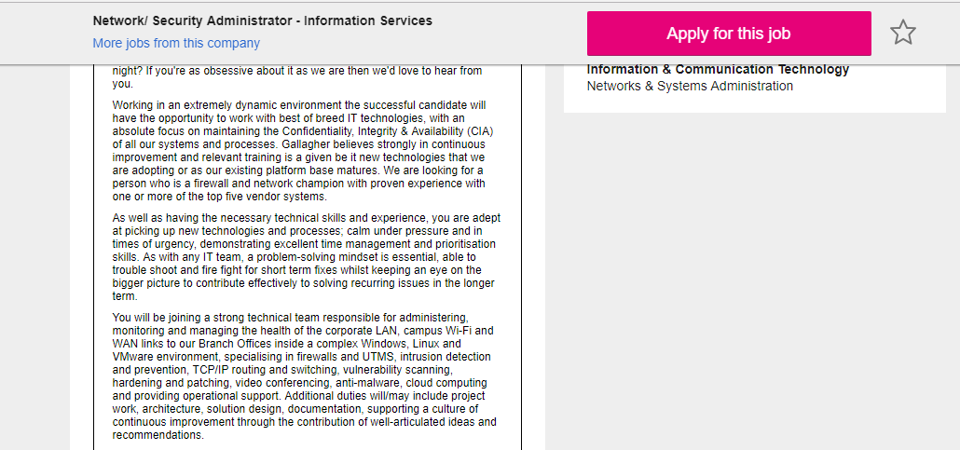

* As description above, this job describes that i am responsible for administering, monitoring and manageing the health of corporate LAN, campus Wi-Fi and WAN and so on.
* I think the task of this job belongs to the step 6 which is “MONITOR Security Controls” in RMF.

Question 2)

The first aspect i choose is 5 which is Lack of available resources

The second aspect i choose is 23 which is lack of training

The third aspect i choose is 33 which is lack of training, academic background of developers.

The situation of The “ lack of available resources” is maybe because of the development of new technologies. We can consider that resources can be anything from materials to personnel.